

JINNAH UNIVERSITY FOR WOMEN KARACHI

BS-I  
 ZOOLOGY

1ST Assignment

SUBMITTED TO:

MISS MARRY MEHWISH

Group Members: Syeda Tooba Zainab, Hafiza Rohma Abid, Beenish Khan,Mehak Rafiq, Lamiah Mansoor,Alina Amjad Ali.

TOPIC;

COLOURFUL PIGMENTATION IN BIRDS

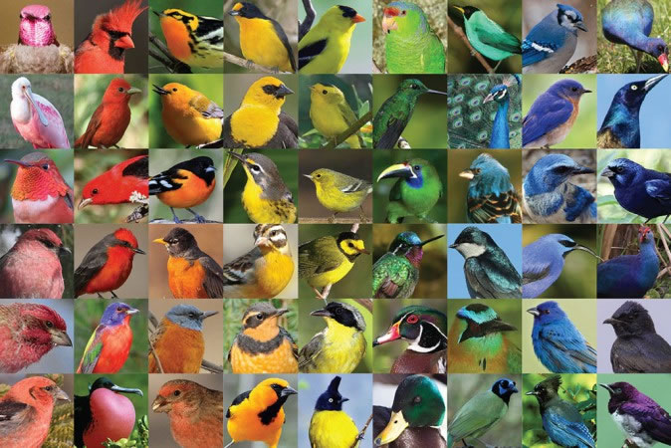

SYEDA TOOBA ZAINAB

**INTRODUCTION:** Biological pigments, also known simply as pigments or biochromes are substances produced by living organisms that have a color resulting from selective color absorption. Biological pigments include plant pigments and flower pigments. Many biological structures, such as skin, eyes, feathers, fur and hair contain pigments such as melanin in specialized cells calledchromatophores.

**H0W BIRD’S FEATHERS ARE COLORFULL?**

As one might expect from the amazing diversity of colors and patterns exhibited by more than 9,000 bird species found in the world, birds can see color. The colors in the feathers of a bird are formed in two different ways, from either pigments or from light refraction caused by the structure of the feather. In some cases feather colors are the result of a combination of pigment and structural colors. The greens of some parrots are the result of yellow pigments overlying the blue-reflecting characteristic of the feathers.

**PIGMENTATION:**

Pigments are colored substances that can be found in both plants and animals. The coloration created by pigments is independent of the structure of the feather. Pigment colorization in birds comes from three different groups: carotenoid, melanin,and porphyrines.  
 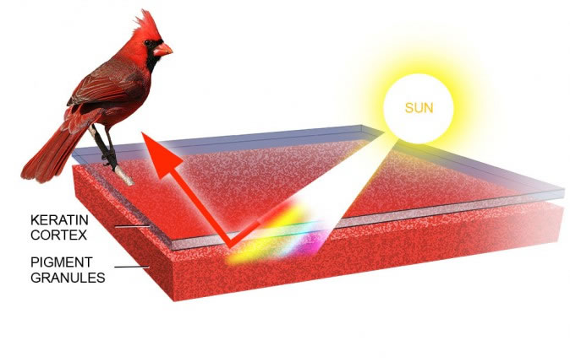

.

# COLOR ABNORMALITIES IN BIRDS

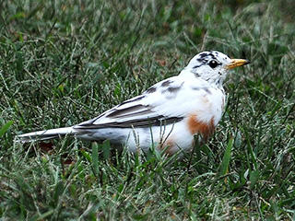

Birds' plumage can sometimes vary due to an excess, or a deficiency, of color pigment in some or all of the feathers. Pigments are compounds that determine the color in birds' feathers.

**Albinism:** Albinism is a genetic abnormality that results in a complete lack of pigmentation in the feathers, eyes, skin, and bill. The result is a completely white bird with a pinkish tint on unfeathered areas of the body caused by blood vessels showing through colorless skin.

## Leucism: The outward appearance of leucistic individuals can vary considerably. "Leucinos" may appear virtually pure white but still possess "normal-colored" eyes and skin; they may possess only a single white feather but otherwise appear normal; or they may exhibit partially white plumage anywhere in between these two extremes. Many older publications refer to this condition as "partial albinism" but, the correct term is leucism.

## Dilution: A bird with a decreased amount of pigmentation resulting in a pale or washed-out appearance has a condition, referred to by Dr. P.A. Buckley, an avian geneticist, as dilution.

## Melanin: The presence of excessive amounts of melanins (dark pigments) cause light-colored feathers to vary from brown to black. Melanins is less common than albinism and leucism.

## Flight Molt : Occasionally some birds (e.g. black-capped chickadees) are seen showing an entirely white tail. While leucism could be responsible for this, it can also be caused by the loss of the tail to a predator. The new "replacement" tail occasionally grows lacking pigment.

**Ultraviolet Feathers:** The feather structures of many species also reflect light in the ultraviolet range. Because many birds can discriminate a greater variety of colors than humans, including ultraviolet wavelengths, they can appear quite different to each other than they do to us.

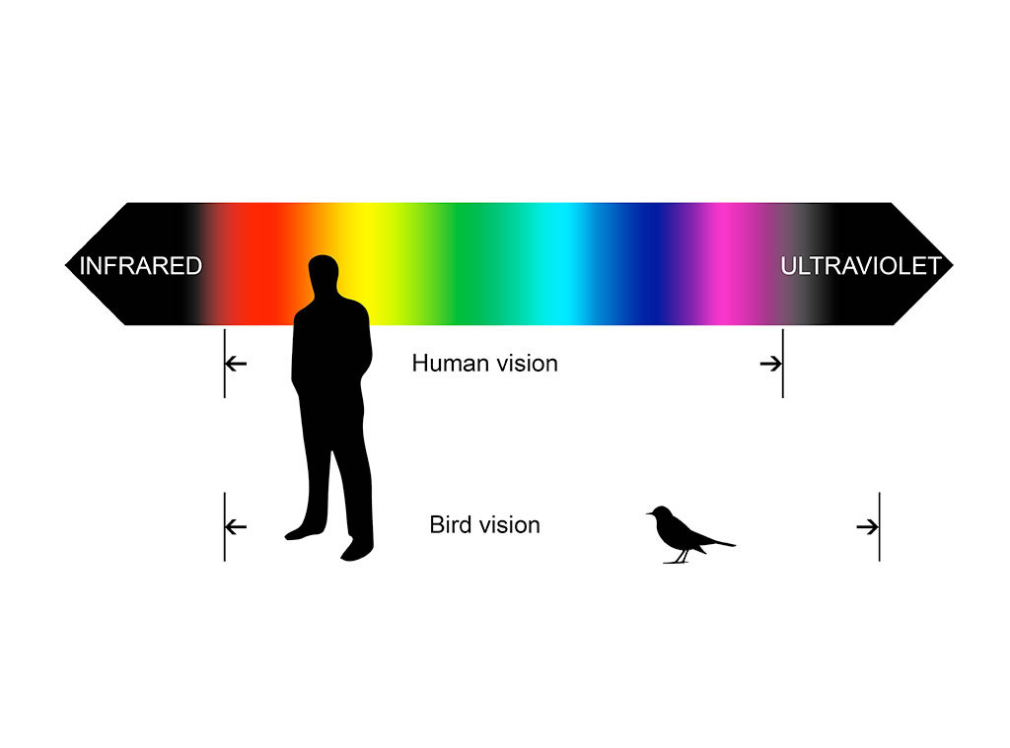

**Wilson's bird-of-paradise**

[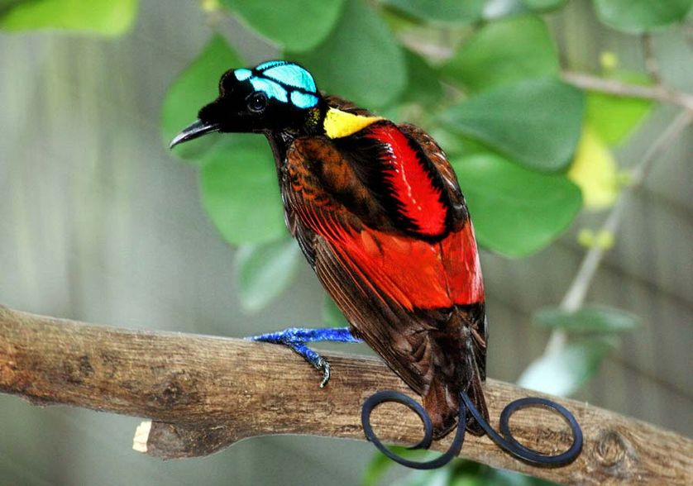](http://media.mnn.com/assets/images/2015/08/Wilson's_Bird_of_Paradise_Best.jpg.838x0_q80.jpg)

A fancy tail doesn’t have to be exceptionally long — it can also be exceptionally well styled. Such is the case with the tail feathers of the Wilson’s bird-of-paradise. The unusual appearance of the bird, starting with its naked blue head, is made all the more interesting by the two violet tail feathers that curl in opposite directions. The bird was filmed in the wild for the first time as recently as 1996.

**Albatross**

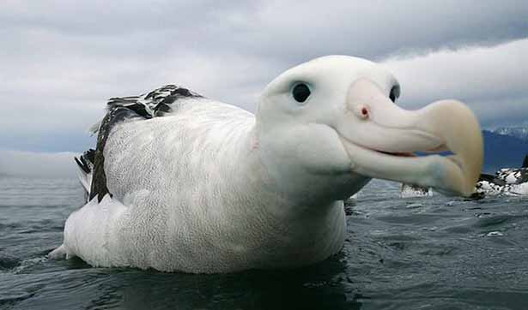

It is a both a rainforest and seabird that depends on fishes for food. In size it looks like a combination of a gull, pelican and parrot. It is one of the most gorgeous tropical birds you’ll ever see. It has dark grey shade on the face and head side and light grey feathers with white spots at the bottom. They are surprisingly one of those rare birds that live to long age, and still declared endangered.

**Booby** –

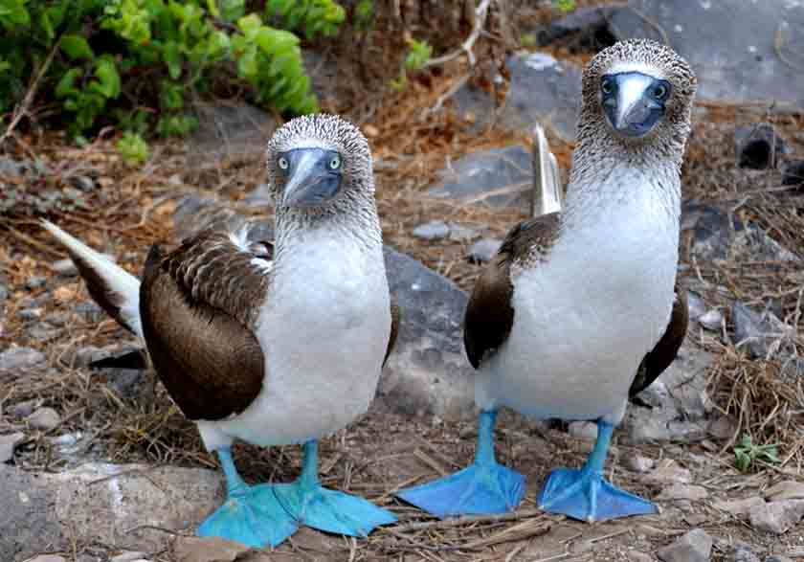

This is one of those rare tropical birds that can swim, fly and swoop to hunt for food. It’s a seabird that quite a large bird and can be as big as pelicans. The bird has a long beak that helps it catch fishes easily. With smooth plumage, wide and long wings, and duck Foot pigmentation

The blue color of the blue-footed booby's webbed feet comes from carotenoids pigments obtained from its diet of fresh fish. Carotenoids act as antioxidants and stimulants for the blue-footed booby's immune function, suggesting that carotenoid-pigmentation is an indicator of an individual's immunological state.[13] Blue feet also indicate the current health condition of a booby. Boobies who were experimentally food-deprived for forty-eight hours experienced a decrease in foot brightness due to a reduction in the amount of lipids and lipoproteins that are used to absorb and transport carotenoids. Thus, the feet are rapid and honest indicators of a booby's current level of nourishment.[13] As blue feet are signals that reliably indicate the immunological and health condition of a booby, coloration is favored through sexual selection like feet makes it a perfect bird that can survive tropical forests environment.

# WHY SOME BIRDS HAVE BRIGHT COLORED FEATHERS ??

Birds have several types of feathers of various shapes and sizes, which are specialized to serve different functions. Feathers enable birds to fly, help to regulate body temperature and provide camouflage from dangerous predators. They are also useful for identification and attracting mates.

Feathers come in a variety of colors, ranging from dull neutrals to bright and sometimes iridescent hues. There are two different sources from which feathers get their color. The colors yellow and red are caused by a pigment in the feather, much like pigments create different skin colors in humans. The brilliant iridescent blue and green colors of a peacock feather are not the result of pigment, but are caused by light refraction. The coloring displayed by some birds is the result of a combination of both of these methods.

Birds’ coloring did not develop at random, but has evolved through sexual selection. Male birds have adapted to help them better attract females of their species. The most obvious example of this is colorful plumage. Large, colorful crests and tails, such as the elaborate “tail of eyes” displayed by the male peacock are examples of feathers being used to attract the opposite sex.

While the males and females of some bird species are nearly identical in color, in most species it is typically the male who is more brightly colored than the female. Birds rely mainly on visual cues when selecting a mate and have extraordinary eyesight with which to discern colors. In the spring, during mating season, males will display brighter, more colorful plumage, sometimes referred to as breeding plumage. The saturated red breast of the robin that is often associated with spring is a good example of this adaptation.

The dull coloring of most females in no accident either. Female birds are most often brown or green, providing them camouflage while they care for their young in the nest. Thus, the bird world is the opposite of the human world, where females are more often “decorated” in an attempt to win the attraction of males. Brightly colored feathers are replaced with colorful clothing and makeup.

Interestingly, while colorful plumage serves to increase a male’s mating success, it actually decreases his chance of survival by making him more easily visible to predators. However, such traits still evolve because they increase mating and reproduction, even if they harm individual survival. A male bird with a small, dull colored tail would probably have a much better chance of survival, but if he did not find another way to attract females, his genes could not be passed down to the next generation.

A few species of birds do exist in which the females are larger and more colorful than than males. Interestingly, in these instances, mating roles are typically reversed. Females of these species rely on their appearance to attract mates while the dull colored males stay in the nest to incubate the eggs and care for the young.

BEENISH KHAN

BS I (ZOOLOGY)

TOPIC:-

REPRODUCTION IN BIRDS

## Introduction:-

Evolution generally has adjusted the timing of avian breeding seasons to maximize the number of young produced. In the temperate, subarctic, and arctic zones, the overriding factor is the availability of food. Abundant nourishment is needed, not only by growing nestlings and juveniles, but also to meet increased energy demands of breeding adults. For females those increased demands include the energetic burden of producing eggs; males need additional energy to support vigorous displays and to defend territories. One or both adults generally participate in the work of building a nest, foraging for more than one individual (mate or chicks), and in some cases territorial defense or guarding young from predators.

For most birds the young hatch and grow when insects are abundant. In the arctic and subarctic, egg laying is concentrated primarily in May and June to take advantage of the late June-early July flush of mosquitoes, black flies, butterflies, and other six-legged prey. The supply is rich near the pole, but the season is short, and birds must court, mate, and nest well before the risk of frigid storms is over. In fact, geese that nest in the arctic arrive on the breeding grounds before the snow is gone, in order to start incubating as soon as nest sites are clear. The geese depend on reserves of body fat to sustain them in an initially food-poor environment.

At least some birds also have "biological calendars" -- internal timing devices that are independent of external environmental cues and tell them when it is time to breed. Consider experiments involving the Short-tailed Shearwater, a Southern Hemisphere species that "winters" in the summer off the Pacific coast of North America but breeds on islands near Australia. Birds were kept in a laboratory for over a year and subjected to a constant light regime, 12 hours of light and 12 hours of darkness, for the entire period. In spite of this constancy, their reproductive organs developed and their feathers molted at the same time as those of Short-tailed Shearwaters in the wild. The physiological basis for biological clocks and calendars -- the mechanisms by which they function -- remains one of the great mysteries of biology.

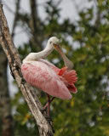

BREEDING SEASON TIMING:-

The breeding season is an ideal time for birding, and knowing when birds mate can help birders plan to attract nesting birds to their backyard, visit isolated lakes to see rare species or just enjoy the beauty of courting birds

The breeding season is an ideal time for birding, and knowing when birds mate can help birders plan to attract nesting birds to their backyard, visit isolated lakes to see rare species or just enjoy the beauty of courting birds

Factors that affect when birds mate include.

* **Geography**: The farther north a bird’s [breeding range](http://birding.about.com/od/birdingbasics/a/Bird-Ranges.htm) is located, the later its mating season will commence. These birds may migrate earlier, however, because they have greater distances to travel in order to reach their ideal breeding locations.
* **Food**: A greater availability of easily accessible food is essential for parent birds to provide adequate nutrition for their chicks. This is [why birds migrate](http://birding.about.com/od/birdbehavior/a/Why-Birds-Migrate.htm) before the breeding season, because moving to a different area where food is abundant helps spread out their population so they will have a better chance of properly feeding their young.
* **Water**: In dry deserts or other arid [habitats](http://birding.about.com/od/Bird-Glossary-H-K/g/Habitat.htm), the sudden appearance of water through seasonal storms or flooding can trigger the mating season. In those types of habitats, plants have evolved to quickly bloom when water is available, and those plants provide the necessary food for birds to raise chicks.
* **Care Period**: [Some baby birds mature quickly while others require their parents’ care for weeks or months](http://birding.about.com/od/Reproduction/fl/How-Baby-Birds-Mature.htm) before they can feed and protect themselves. The more care a baby bird requires or the longer the initial [incubation](http://birding.about.com/od/birdingglossary/g/incubation.htm) period for the eggs, the earlier the mating season will be soparents have enough time to raise the chicks before environmental conditions worsen.
* **Brood Numbers**: If a bird species raises multiple [broods](http://birding.about.com/od/birdingglossary/g/glossbrood.htm) each year, the mating season is typically earlier so there is plenty of time for each brood to be cared for as the eggs are incubated and the chicks mature. Birds that can raise multiple broods may not always have a second or third brood, however, if conditions are not favorable for the chicks to survive.
* [**Nesting Sites**](http://birding.about.com/od/birdhouses/a/Bird-Nest-Identification.htm): Where a bird builds a nest can affect the time it mates. [Cavity-nesting](http://birding.about.com/od/Bird-Glossary-C-D/g/Cavity-Nesting.htm) species that reuse the nest cavities of other birds may breed later in the season so more nesting sites have already been abandoned after earlier successful nests. Birds that build new nests each year may also nest later in the season, while birds that reuse old nests each year can mate earlier and still have a suitable location to raise their young.

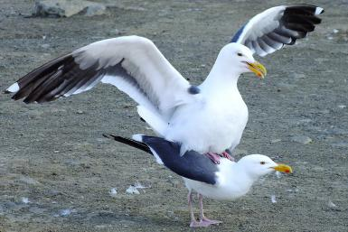

SIGNS OF THE MATING SEASON :-

Spring is the typical mating season for most bird species because food sources are increasing, melting snows and spring rains provide plenty of water and there will be a long, temperate season for birds to mature before winter arrives. But just like spring migration varies in different areas and for different species, when birds mate in spring also varies. Birders can watch for signs of the breeding season, however, to learn when .local birds are feeling reproductive urges.

To pinpoint when the bird mating season occurs, watch for:

• Warming temperatures and blooming flowers that show the change of seasons.

• Birds claiming territory and becoming more aggressive toward intruders, particularly males.

• The appearance of bright breeding plumage with fresh, clear markings.

• Increased bird song, which can help define territories and attract mates.

• Bird courtship behavior, including elaborate display flights and other bonding.

• Dissipation of large winter flocks or mixed foraging flocks as birds pair off with mates.

• The collection of nesting materials and the beginning of nest building activities.

While the nesting season may be a few weeks long for each species as they claim a territory, attract a mate and raise one or more broods of chicks, the actual mating period for birds may last only a week or two as individuals are receptive to the act of copulation, and the mating itself may be just a few seconds or minutes.

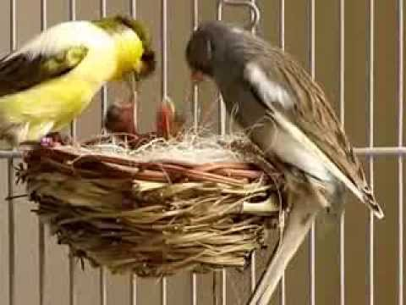

### THE REPRODUCTIVE ANATOMY OF BIRDS

Most birds do not have the same reproductive body parts as [mammals](http://animals.about.com/od/mammals/p/mammals.htm). Instead, both male and female birds have a [cloaca](http://birding.about.com/od/Bird-Glossary-C-D/g/Cloaca.htm) – one opening (also called the vent) that serves as the bodily exit for their digestive, urinary and reproductive systems. This means that the same opening that excretes [feces](http://animals.about.com/od/f/g/feces.htm) and urine is where eggs are laid. During the breeding season, the cloaca swells and protrudes slightly outside the body, while during the rest of the year it is much less prominent.

When birds are ready to breed, their reproductive organs – the testes and ovaries – swell and produce the sperm and ova. Male birds store sperm in their cloaca until an opportunity to mate arises, and females will receive that sperm into their cloaca before it travels to fertilize their ova.

**BIRD COURTSHIP BEHAVIOUR**

Understanding bird courtship can help birders better appreciate the challenges birds face in finding suitable mates to raise the next generation. This type of behavior can be fascinating to witness, and when birders recognize courting birds, they can be sure to avoid disturbing these delicate rituals.

Understanding bird courtship can help birders better appreciate the challenges birds face in finding suitable mates to raise the next generation. This type of behavior can be fascinating to witness, and when birders recognize courting birds, they can be sure to avoid disturbing these delicate rituals.

Why Birds Use Courtship Rituals ??

The ultimate purpose of courtship is to attract a receptive mate, but there are actually several other purposes behind the courtship behavior of different bird species. The intricate moves of a mating dance and the charming songs used to woo partners can help distinguish species so birds are sure to choose compatible mates. Different courtship behaviors also reduce territorial aggression between birds, letting them relax together to form a pair bond. Depending on the type of behavior, how the birds react in courtship can also display strength, health and mating desirability, allowing different birds to choose the best partners and ensure viable, healthy offspring

Types of Bird Courtship Behavior

There are several different courtship rituals birds use [for finding a mate](http://birding.about.com/od/birdingbasics/a/mateforlife.htm). Most species will use one method overwhelmingly but may actually have several methods they use to lesser degrees. The exact type of courtship can vary greatly between different species, and even birds of the same species may have slightly different courtship variations in different regions.

* **Singing**: Singing is one of the most common ways birds attract mates. The intricacy of the song or the variety of different songs one bird can produce help advertise its maturity and intelligence – desirable characteristics for a healthy mate. Singing can also define the boundaries of one bird’s territory, warning off competition. For some species, only one gender (usually males) will sing, while other species may create a duet as part of the bonding ritual.
* **Displays**: Flamboyant [plumage](http://birding.about.com/od/birdingglossary/g/glossplumage.htm) colors and elaborate displays of prominent feathers, skin sacs or body shape can show off how strong and healthy a bird is, advertising its suitability as a mate. Peafowl are one of the best known bird species for their stunning display with the males’ extensive [upper tail covert](http://birding.about.com/od/Bird-Glossary-U-Z/g/Uppertail-Coverts.htm) fan, though other birds may use subtle changes in posture to show off their plumage to the best effect, such as raising a crest or flaring their wings.
* **Dancing**: Physical movements, from daring dives to intricate sequences including wing flaps, head dips, bill rubbing or different steps can be part of a courtship ritual. In many species, the male alone will dance for his female while she observes his actions, while in other species both partners interact with one another. Dance mistakes show inexperience or hesitancy and would likely not lead to a successful mating.
* **Preening**: Close contact between male and female birds can be part of the courtship rituals to help diffuse their normal spatial boundaries and aggression. The birds may lightly [preen](http://birding.about.com/od/birdbehavior/a/Preening.htm) one another, sit with their bodies touching or otherwise lean on one another to show that they are not intending to harm their partner.
* **Feeding**: Offering food is another common part of courtship for many species. Typically a [male bird](http://birding.about.com/od/identifyingbirds/a/genders.htm) may bring a morsel to the female, demonstrating that he is able not only to find food, but that he can share it and is able to provide for her while she [incubates eggs](http://birding.about.com/od/birdingglossary/g/glossbrood.htm) or tends helpless chicks. For some species the male may just bring food and transfer it to the female for her to feed, while in other species he will place a seed or insect directly in her mouth just as he might be expected to do when helping feed hungry [nestlings](http://birding.about.com/od/birdingglossary/g/nestling.htm).
* **Building**: Some birds seek to attract a mate by showing off their architectural skills. Constructing nests before the female arrives is a way for males to [claim territory](http://birding.about.com/od/birdbehavior/a/How-Birds-Claim-Territory.htm) and show the suitable nesting areas they can defend. They may also decorate the nest with pebbles, moss, flowers or even litter to make it more eye-catching. The female may then choose the nest she prefers, or she may still build her own after mating with her chosen male.

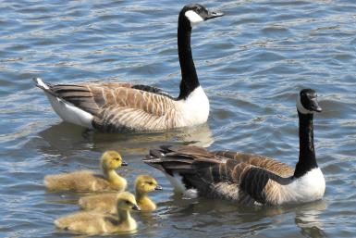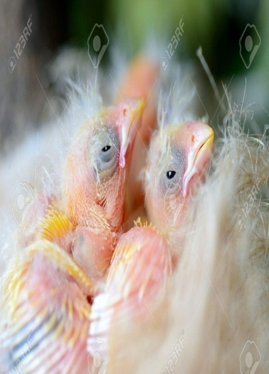

## THE INCREDIBLE FEMALE BIRD REPRODUCTIVE SYSTEM

**by Linda Pesek DVM**

The avian female reproductive tract has evolved over time into a complex structure, unique to birds. The process of forming and laying an egg is one of nature's many wonders.

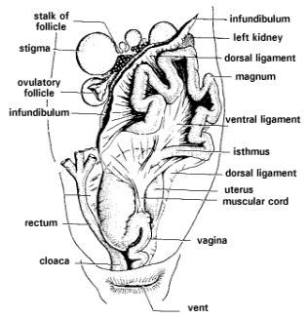Just like many other female animals, the avian female begins life with two ovaries and oviducts. However, in most species of birds, the left ovary and oviduct grow more rapidly than the right, and the right side regresses, leaving only the left ovary and oviduct. Some people believe that this is an adaptation to reduce weight, necessary to aid flight.

At hatching, the left ovary contains all of the egg cells it will ever have. These cells will continue to develop once the hen reaches an age when she is able to reproduce.

Female birds may be determinate or indeterminate egg layers. Determinate layers are those birds that only lay a set number of eggs - such as crows or budgies. Indeterminate layers - such as parrots - will quickly replace any eggs that are lost, thus not laying a set number of eggs. Breeders utilize this by removing eggs and artificially incubating them, thus encouraging more eggs to be laid.

The female reproductive tract is divided into several parts. It takes approximately 25 hours for an egg to travel from the beginning to the end. The first part of the female reproductive tract is the infundibulum. This consists of a) a funnel which captures the ovulated egg and b) a tubular region known as the chalaziferous region. Sperm fertilizes the egg in the funnel portion of the left oviduct. However, a female will lay eggs even if there has been no mating to fertilize them. The egg then passes on to the chalaziferous region. Here a layer of albumen, known as the chalaziferous layer, and the chalazia which suspend the yolk, are secreted by glands in the tubular region. The egg remains in the 1st part of the reproductive tract for 15 minutes.

The second part of the oviduct is the magnum. This is the longest and most coiled portion of the oviduct. It is very thick walled and contains many tubular glands which secrete albumen, sodium, magnesium and calcium. The egg remains in the magnum for three hours.

The isthmus is a short portion of the oviduct. During the 75 minutes the egg remains here, the inner and outer shell membranes which line the shell are formed and calcification is initiated.

The uterus or shell gland is the place the egg remains the longest, from 20 - 26 hours. The shell of the egg is secreted here and "plumping" occurs. Plumping is the rapid addition of watery solutions to the egg, which doubles the weight of the albumen.

The final part of the female reproductive tract is the vagina. The egg passes through this portion very rapidly as it is laid.

Sperm may be stored in specialized glands known as sperm host glands which are located in the vaginal sphincter for a few days. The sperm travel up to the infundibulum to fertilize the egg.

Most psittacines (parrots) lay their eggs every two days, while passerines (finches and canaries) and chickens usually lay an egg every 24 hours during their laying cycle.

The ovary is under complex hormonal control. In birds that are seasonal egg layers, the left ovary undergoes three phases of development. During the first phase, the prenuptial acceleration, the ovary enlarges. The second phase, the culmination phase, is when ovulation and egg laying occur. The third phase is the refractory period during which the ovary regresses in size until the next time.

During the early stages or late stages of egg laying, the infundibulum may fail to catch the ovulated egg and it may enter the abdominal cavity. This is known as "Internal Laying". The egg may be absorbed or it may lead to an inflammatory process known as egg yolk peritonitis.

# Birds Reproduction

Bird reproduction starts the same way as in mammals by the joining of an egg or ovum with a sperm cell in the oviduct. This fertilized ovum then forms the nucleus of the egg and the formation of the yolk, whites and shell can begin. The sperm from the male is transferred to the female when they touch cloaca, an act referred to as the cloacal kiss.

**Egg Formation**

The first animals to develop the use of eggs with shells were the reptiles, in order that the egg would not dry out when not laid in water. With birds evolving from reptiles they have also made use of this incredible adaptation although they have taken it even further developing the egg into an amazing life support system for the growing embryo.  
  
Most animals have two ovaries and oviducts, the passage for the egg to travel to the uterus. Birds however only have one and as the fertilized ovum travels down it a layer of albumen is applied around it, followed by the shell membranes. The shell itself is formed in the uterus where, depending on the movement of the egg, pigmentation forms patterns in the shell material.

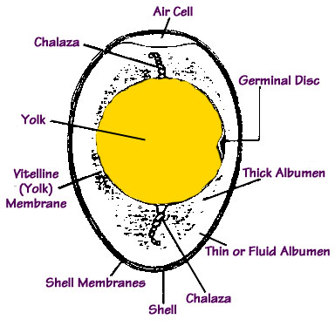

**[Egg Structure](http://birding.about.com/od/birdingbasics/a/mateforlife.htm" \o "Pin to Pinterest)**

[An egg comprises several main elements, the yolk, the albumen, the membranes and the shell. The yolk is a fat rich food store with a small white spot, known as the germinal spot, and it is from here that the embryo begins to develop.  
  
The whites of the egg, the albumen, supplies the embryo with water, provides some shock protection and helps gases to move in and out of the egg during development.  
  
The membranes are three in number, one around the yolk known as the vitelline membrane, and two around the albumen, the inner and outer shell membranes. They provide a barrier against bacterial penetration and the air sac or air cell forms between the two shell membranes.   
  
The shell is comprised of protein fibers and calcium carbonate or chalk merged into a complex mesh like structure and despite its smooth appearance is permeable to gases. It allows oxygen through to the growing embryo and waste gases and moisture to escape the egg. As the embryo develops the air sac increases in size and allows the mature chick its first breath.   
  
There are also two twisted strands in the albumen attached to the yolk, called the chalaza, which hold the yolk in place and suspend the growing embryo in safety.  
  
The yolk and albumen provide much for the developing embryo and all it needs from the outside world is oxygen and warmth.  
  
The shape of most eggs is, obviously, egg shaped, but there are those that are adapted to suit particular circumstances. As an example cliff nesting birds have more pointed eggs, which makes them roll in a tight circle so they don’t fall off the cliff if disturbed.](http://birding.about.com/od/birdingbasics/a/mateforlife.htm" \o "Pin to Pinterest)**[Laying schedule](http://birding.about.com/od/birdingbasics/a/mateforlife.htm" \o "Pin to Pinterest)**

[The timing and number of clutches of eggs produced by different species varies dependent upon circumstances. The](http://birding.about.com/od/birdingbasics/a/mateforlife.htm" \o "Pin to Pinterest)[[BlueTit](http://birding.about.com/od/birdingbasics/a/mateforlife.htm" \o "Pin to Pinterest)](http://www.twootz.com/bird/Blue-Tit)[, for instance, feed their young mainly on insect larvae and so tend to produce one large clutch in early summer when this food source is more abundant. Conversely the](http://birding.about.com/od/birdingbasics/a/mateforlife.htm" \o "Pin to Pinterest)[[Blackbird](http://birding.about.com/od/birdingbasics/a/mateforlife.htm" \o "Pin to Pinterest)](http://www.twootz.com/bird/Blackbird)[will lay two or three smaller clutches as they have a more abundant, steady food source and therefore have longer to raise multiple clutches.  
  
Both of these situations however still share the same incubation behavior. The female will lay one egg per day until the clutch is complete and it is only at this point that incubation starts. Even though the eggs may have different ages, this method of incubation results in all the young hatching around the same time and all have an equal chance at feeding time and for survival.  
  
Some species such as birds of prey as well as others lay eggs two or three days apart and start incubation as soon as the egg is laid. This means that the young hatch at different intervals and when food is scarce the youngest hatchlings will not be able to compete for food and will not survive. In hard times such as this these fatalities will even become food for its erstwhile brothers and sisters and although this seems a bit gruesome after all the effort invested in breeding it helps prevent all the chicks being lost in harsh conditions.](http://birding.about.com/od/birdingbasics/a/mateforlife.htm" \o "Pin to Pinterest)**[Camouflage](http://birding.about.com/od/birdingbasics/a/mateforlife.htm" \o "Pin to Pinterest)**

[The color of the eggs varies with different species and nesting habits. Birds that build their nests in holes tend to have light colored eggs, white or blue, that are easier to locate in dark conditions and so avoid accidental damage. The hidden nature of the nesting site provides the camouflage. Ground laying birds, such as plovers, produce highly camouflaged eggs to prevent. Although](http://birding.about.com/od/birdingbasics/a/mateforlife.htm" \o "Pin to Pinterest)[[Cuckoos](http://birding.about.com/od/birdingbasics/a/mateforlife.htm" \o "Pin to Pinterest)](http://www.twootz.com/bird/Cuckoo)[already produce variably colored and patterned eggs they do have the ability to mimic the appearance of other species eggs.  
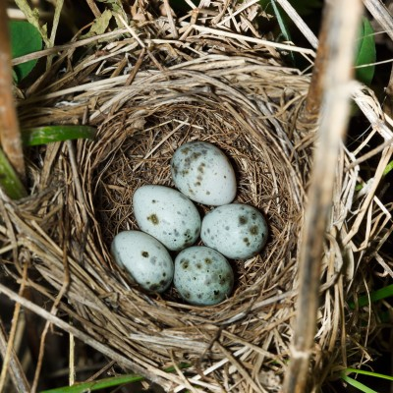](http://birding.about.com/od/birdingbasics/a/mateforlife.htm" \o "Pin to Pinterest)**[Incubation](http://birding.about.com/od/birdingbasics/a/mateforlife.htm" \o "Pin to Pinterest)**

[In most cases it is the female parent that incubates the eggs and to help transfer heat effectively she will develop a brood patch as the breeding season approaches. This brood patch has an area of skin with densely packed blood vessels and hardly any feathers, which produces more heat, due to the blood vessels, and this is transferred more easily to the egg due to the lack of feathers. Eggs are also turned periodically to ensure an even distribution of warmth. In species where the males also incubate eggs they will also develop a brood patch but they spend much less time at this than females. In all cases, however, the brood patch will disappear at the end of the breeding season.](http://birding.about.com/od/birdingbasics/a/mateforlife.htm" \o "Pin to Pinterest)**[Hatching](http://birding.about.com/od/birdingbasics/a/mateforlife.htm" \o "Pin to Pinterest)**

[It is possible that a developed chick may be able to communicate with its parent a day or two before hatching by answering its parents call with some vocal sounds. It will then start to use the hard tip of its bill, called the egg-tooth, to break out of the egg by laying on its back and pushing the egg-tooth into the shell above it. Once it has weakened the shell enough it will try to push the two halves of the eggshell apart. This may take a few days to accomplish and after a few days of hatching, the young lose the egg-tooth.](http://birding.about.com/od/birdingbasics/a/mateforlife.htm" \o "Pin to Pinterest)

### [Nestlings](http://birding.about.com/od/birdingbasics/a/mateforlife.htm" \o "Pin to Pinterest)

[Hatchlings fall into two main categories, nidicolous and nidifugous. Nidicolous hatchlings are practically helpless, blind and naked, are wholly dependent on their parents and do not leave the nest until fledged. They tend to belong to species with the shorter incubation such as](http://birding.about.com/od/birdingbasics/a/mateforlife.htm" \o "Pin to Pinterest)[[Blue Tit](http://birding.about.com/od/birdingbasics/a/mateforlife.htm" \o "Pin to Pinterest)](http://www.twootz.com/bird/Blue-Tit)[.  
  
Nidifugous hatchlings are born with a covering of downy feathers and are able the leave the nest and fend for themselves. Many species of duck, Moorhen and Coot have nidifugous young.](http://birding.about.com/od/birdingbasics/a/mateforlife.htm" \o "Pin to Pinterest)

**Juveniles**

like their parents, as in the [Wren](http://www.twootz.com/bird/Wren), or may be considerably different, as in the [Robin](http://www.twootz.com/bird/Robin). Juvenile birds are those that have developed their first flight feathers and are able to leave the nest and fend for themselves. They may look very much

**Disturbing Birds**

It is against the law in the UK to disturb wild birds or their eggs, punishable by fines and even imprisonment. There are individuals who collect eggs but this is wholly illegal, not to mention immoral and distribution.

MEHAK RAFIQ

BS I (ZOOLOGY)

TOPIC:-

|  |
| --- |
|  |
|  |

BIOLOGICAL AND PHYSIOLOGICAL ADAPTATIONS OF BIRDS

# Introduction :

In scientific taxonomy, birds are members of kingdom Animali and phylum Chordata. At the next level, birds are put into their own group: Class Aves.

Class Aves: worldwide, there are 27orders of birds. Within those orders, there are hundreds of bird families. Within those families, there are approximately 10,000 speies of birds.

**Understand adaptations that make flight possible**

* Skeleton
* Musculature
* Respiratory System.
* Circulatory System.
* Digestive System.
* Reproduction.
* Senses
* Feathers

# **Fossil Record** (Archaeopteryx)

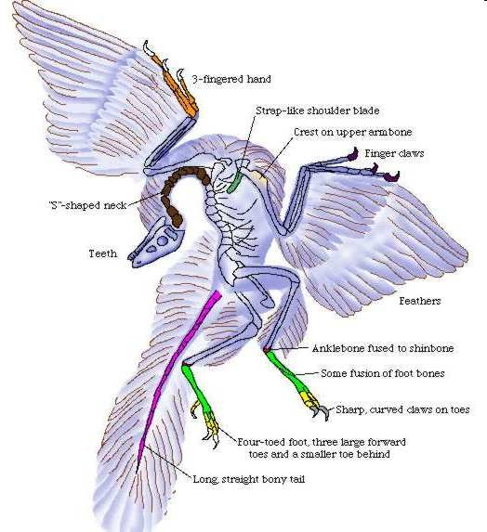 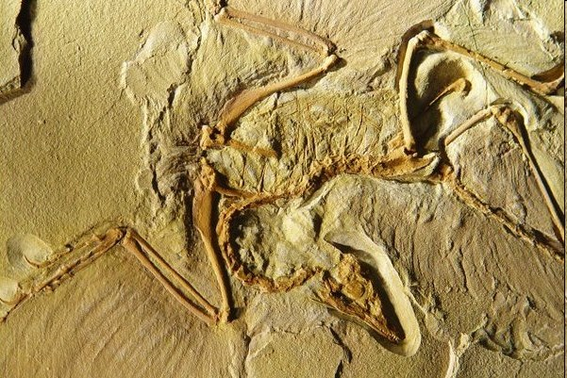

## Skeletal Adaptations

The sternum (breastbone), bears a prominent keel where the flight muscles attach. The furcula (wishbone), serves as a brace during the flight stroke Secondary feathers of the wing are supported by the forearmWrist and hand bones are fused to provide firm support for the primary feathers.

## Light but Powerful Musculature

## Most birds have approximately 175 different muscles, mainly controlling the wings, skin, and legs The largest muscles control the wings and run between the upper arm and the keel The pectoralis major provides the powerful down stroke The supra coracoide us muscle raises the wing Uses a pulley-like system to lift the wing. These muscles constitute about 20 – 25percent of the bird's total body mass.

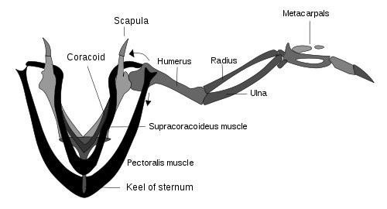

## Respiratory System

These structures are unique to birds Due to the high metabolic rate required for flight, birds have a high oxygen demand Birds ventilate their lungs by means of air sacs.

, and perhaps dinosaurs, too

Birds’ lungs obtain fresh air during both exhalation and inhalation

Birds lack a diaphragm.

The entire body cavity acts as a bellows to move air through the lungs

The active phase of respiration in birds is exhalation, requiring muscular contraction .Air flows through the air sac system and lungs. There is no mixing of oxygen-rich air and oxygen poor, carbon dioxide-rich air as in mammalian lungs.

The partial pressure of oxygen in a bird's lungs is the same as the environment. Birds have more efficient gas-exchange of both oxygen and carbon dioxide than do mammals.

## Circulatory System

## Makes possible a Birds, like mammals, have four-chambered hearts double circulation. Bird’s heart is large, powerful, and rapid in its beat

Animal Heart as % of Body Weight Heart Beats per Minute

Boa constrictor 0.31 20

Bullfrog 0.32 22

Man 0.42 78

Dog 1.05 140

Vulture 2.07 301

Crow 0.95 345

Sparrow 1.68 460

Hummingbird 2.37 615

A bird’s digestive system can assimilate food at an extremely rapid rate

Most birds have digestive tracts adapted to their diet.

* Herbivores
* Carnivores
* Omnivores

## Herbivores

Feed on seeds, fruit, and other vegetable matter

Have a storage sac called the crop where food is macerated before it passes to the two-chambered stomach

Mixed with digestive juices in the first part

Ground into a pulp in the second part (the gizzard)

Herbivorous birds swallow small stones which assist the grinding of food in the gizzard.

## Carnivores

Feed on fish, animals, insects, and carrion. Do not usually have a crop If they do, it is small. The gizzard is less muscular Functions as a normal Stomach Some carnivores do not attempt to digest the bones and fur or skin of their prey. Regurgitated in the form of a hard pellet.

The pancreas is slightly more well developed in birds than in mammals

Possibly as partial compensation for the lack of saliva and chewing

It produces enzymes for digesting carbohydrates, fats, and proteins .The liver has two distinct lobes each with its own duct leading into the small intestine. Stores the bile.

In birds, the bile is acidic and not alkaline as it is in mammals.

## Excretory System

## Another weight reducing adaptation in birds is the absence of A urinary bladder a urethra is The kidneys excrete nitrogenous wastes in the form of uric acid.

## Adaptations of the Reproductive System

## Birds are the only class of vertebrates in which no species give birth to live young. Nearly all species possess only one ovary and oviduct. They lay their eggs in the nest soon after the eggs are formed Reproductive structures atrophy during the non-breeding season.

## Vision

## Birds have acute eyesight

## Hawks are able to discriminate fine details at a much greater distance and much more quickly than humans. Hawks have a bony "brow" above the eye known as a *supraorbital ridge*. Raptors including owls have a "third eyelid" known as a *nictitating membrane* Eyes of a bird are relatively large.

## Hearing

As an adaptation for flight, birds lack an externally visible ear. The range of hearing in many species of birds is comparable with that of mankind Some birds have hearing that is much more sensitive than ours Owls not only. are more sensitive to small sounds but they have asymmetrical earsAllows them to pinpoint the source of a sound extremely accurately.

## Smell

The olfactory lobes of most birds are very small, suggesting that they have a poor sense of smell. Some birds do use smell to locate food.

* Sea birds (Petrels, Shearwaters).
* Vultures.
* Kiwis.

## Feathers

Of all the organisms on earth, only birds have feathers.

* They are instrumental in flying.
* They play a critical role in temperature regulation.
* Their color patterns are essential in both display and camouflage.
* The mass of feathers on a bird’s body constitutes its plumage
* Feathers clump in distinct tracts with featherless areas in between

Birds’ color patterns are built of these units Worn feathers are periodically.

ALINA AMJAD ALI

TOPIC :-

**TYPES OF BIRDS** There are two types of birds:-

The first one is pet and the second is wild birds,some of these birds are follows:-

PET BIRDS

.DIOMOND DOVE:

The diamond dove is a tiny, delicate-looking bird whose body is about the size of a lovebird, but with a long, slender tail. The nominate bird, or the color of the bird most often found in nature, is a darkish-gray with white specks on the wings, though there are now mutations, including white and silver. The diamond dove is dimorphic, meaning that there is a visible difference between the sexes: both sexes have a red eye-ring, though the male’s ring is larger. This makes pairing easy, which is a plus for the beginning hobbyist.

Native Region / Natural Habitat:

The diamond dove is native to Australia, where they are found in the dry deserts in the north and central parts of Australia

Personality & Behavior:

Diamond doves will not necessarily want to interact with you, unless you purchase a hand-fed bird, or you hand-feed your pair’s babies yourself. These birds are content to be together and breed. They are gentle, and will not bite you when handled. Diamond doves are not ideal pets for children, who may want a bird that they can hold and pet. These birds do well in a garden aviary setting where they can fly and interact with nature and one another. Beware of adding larger or more aggressive birds, however, because your doves do not have the ability to defend themselves against them. These birds are social and if they are not bonded to people, they will need a dove companion.

Speech & Sounds:

Doves are not generally loud bids, though you will hear some cooing from your pair. If you are used to a louder, parrot-type bird, you will be pleased at the relative lack of noise from your doves. These birds are great for an older person or an apartment dweller that wants to own birds, but may not want the noise that accompanies them. Remember, as with all birds, the more you have, the louder they will be-this is especially important to remember with doves, as they will breed you out of house and home if you let them.

Care & Feeding:

Doves have different housing needs than parrots. Doves are unable to climb up the cage bars like parrots ca; instead they move about by flying back and forth, which makes a wide cage an important feature. Diamond doves spend a good part of their day on the ground so they should have plenty of room to walk about. Offer a variety of perch styles and of varying diameters, which will help promote good foot health in your dove. Doves also need opportunities for bathing. Doves, unlike parrots, do not crush their seed with their beak, and will need some grit in their diet. Feed a good seed mixture, and offer plenty of greens and soft fruits. A well-cooked hardboiled egg and egg food will be appreciated during breeding time. These birds will breed well in an open nest, a bit larger than a canary’s nest, with a liner and nesting material added. Make sure to rest your birds for a few months every two clutches, or risk exhausting your birds, lessening their lifespan. Keep your doves in as large a cage as you can afford; because your doves may never leave the cage, it’s important that you provide for as much exercise as possible. A hen that can’t exercise may become egg bound and die. These birds are reported to live for up to 10 years when cared-for properly.

Health & Common Conditions:

Doves are susceptible to red mites, which hide during the day and come out at night to feed on the bird’s blood, and doves housed outdoors are susceptible to roundworms, tapeworms and other worm species. Canker, a respiratory disease that shows as a swelling in the dove’s throat and a cheesy looking growth around the mouth, can be fatal if not treated. Those who keep pigeons should wash their hands after handling, feeding or cleaning the dove’s housing because doves can transfer Chlamydia and Salmonel (bacterial infections) to people. Overall, doves are generally healthy birds 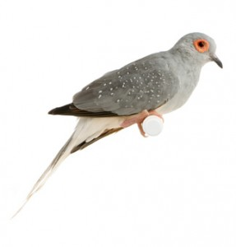 .GOLDIES LORIKEETS: Scientific Name: Psitteuteles goldiei

Size: 7.5 inches

Native Region: New Guinea

Life Expectancy: 20 years

Noise Level: Low

Talk/Trick Ability:

Moderate, but not as chatty as other lories. Traits: The Goldie’s lorikeet has a calm demeanor, which makes it less high-maintenance than other lories. Goldie’s lorikeets make good pet birds because they are calm and content with staying perched where they remain less hyper than other lory species. The Goldie’s lorikeet is very curious, so supervise playtime and be sure their cage bars have appropriate spacing.

Behavior/Health Concerns: Goldie’s Lorikeets are susceptible to hemochromatosis or iron-storage disease. They need nectar as the base of their diet. The nectar or powder diet should be low iron. Fresh fruits are also good foods to add to the nectar and/or powder bird diet add to the nectar and/or powder bird diet. 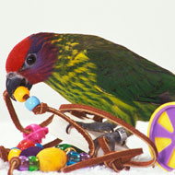

.PACIFIC PARROTLET:

The Pacific parrot let has become one of the more popular small birds in the country, and is the most common of the various parrot let species. They are referred to as “pocket parrots” — because of their small size, and they might very well sit in your shirt pocket as well! They have the personality of a “large bird in a small bird’s body,” and are often compared to Amazon parrots, a family of parrots said to be their close cousins. Indeed, they do resemble the Amazons, with short, stout bodies and a somewhat blunt tail. The male is green with a blue streak behind the eye and blue on the rump and wing-coverts. Females lack the blue coloring, and may or may not have a faint blue streak behind the eye

Native Region / Natural Habitat:

Pacific parrot lets are native to Mexico and Central and South America

Personality & Behavior:

Parrot lets in general are feisty, affectionate and willful. If someone wants a great companion they should keep only one bird, because a pair of parrot lets will probably bond closely to each other to the exclusion of the owner. However, parrot lets are dimorphic and easy to pair up, and they do enjoy each other’s company. They can also be kept peaceably in groups in large aviaries, but it’s best to keep them separate from other species. They will quibble and fight over object and territory, so keep that in mind.

Males and females make equally good companions depending on the individual. Companionability has much less to do with gender than it does with handling and socialization. Hand-fed parrot lets are very parrot let can lose some of its companionability. The Pacific, in particular, does not understand that it is a tiny bird, and has little trouble challenging other animals and humans.

The mutations are said to be more easy going than the nominate color (green), but they are also said to be less hardy. This may be a result of inbreeding. Because of the small size, the parrot let may seem like a great companion for children, but kids would probably be better off with a budgie or something in the neophema family. The parrot let can be temperamental and feisty, and its bite packs a wallop.

Speech & Sounds:

Pacific Parrot lets are not noisy birds, making them great for people living in apartments. They will repeat words and simple phrases, but are not known to be the finest talkers of the parrot let family. These birds can learn to mimic, but they aren’t the best talkers of the parrot family. Some individuals can learn quite a few words, however. They aren’t noisy, so neighbors won’t be disturbed.

Care & Feeding:

Parrot lets might be small but that doesn’t mean that a small cage will do. A spacious wide cage with 1/4 inch bar spacing is ideal. These are active birds that need their play space and plenty of toys to keep them busy. Parrot kabobs and other shred able toys are parrot et favorites, and they also like swings and doings.

Parrot lets should have a pellet-based diet supplemented with fresh fruits and vegetables, as well as some seed. They also need a calcium source, such as cuttlebone. You might have to dice up their fruit so they can sink their tiny beaks into it.

Parrot lets should have a pellet-based diet supplemented with fresh fruits and vegetables, as well as some seed. They also need a calcium source, such as cuttlebone. diced fresh fruits and vegetables are also important for these birds. Some parrot let-friendly fruits and vegetables are corn, bananas, oranges, carrots, pears, apples, peas, celery, pomegranates, green beans and kiwi. Allow tiny portions of nuts and seeds — but never more often than one serving per day. Dietary supplementation for calcium is also crucial. Cuttlebones, which are cuttlefish shells, are suitable for these purposes.

Health & Common Conditions:

A parrot let’s curiosity, combined with its small size, can make it accident prone and being stepped on can pose a real hazard.

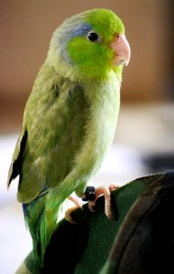

2.WILD BIRDS:

.FIAMINGOS:

Flamingos or flamingoes are a type of wading bird in the genus Phoenicopterus, the only genus in the family Phoenicopteridae. There are four flamingo species in the Americas and two species in the Old World. These famous pink birds can be found in warm, watery regions on many continents. They favor environments like estuaries and saline or alkaline lakes. Considering their appearance, flamingos are surprisingly fluid swimmers, but really thrive on the extensive mud flats where they breed and feed.

Greater flamingos are likely to be the only tall, pink bird in any given locale. They also have long, lean, curved necks and black-tipped bills with a distinctive downward bend.

Their bent bills allow them to feed on small organisms—plankton, tiny fish, fly larvae, and the like. In muddy flats or shallow water, they use their long legs and webbed feet to stir up the bottom. They then bury their bills, or even their entire heads, and suck up both mud and water to access the tasty morsels within. A flamingo's beak has a filter like structure to remove food from the water before the liquid is expelled.

Shrimplike crustacean are responsible for the flamingo's pink color. The birds pale in captivity unless their diet is supplemented.

Greater flamingos live and feed in groups called flocks or colonies. They find safety in numbers, which helps to protect individual birds from predators while their heads are down in the mud. Greater flamingos also breed while gathered in groups. Once mating is complete, a pair takes turns incubating their single egg. Young flamingos are born gray and white and do not turn pink for two years. In years when wetlands and pools are dry and food scarce, flamingoes may not breed

. 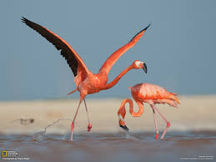

.BARN OWL:

The barn owl is the most widely distributed species of owl, and one of the most widespread of all birds Scientific name: Tyto alba

Conservation status: Least Concern (Population stable)

Mass: 0.95 – 1.4 lbs

Higher classification: Tyto

Rank: Species

Length: 13 – 16 in.

Ghostly pale and strictly nocturnal, Barn Owls are silent predators of the night world. Lanky, with a whitish face, chest, and belly, and buffy upperparts, this owl roosts in hidden, quiet places during the day. By night, they hunt on buoyant wing beats in open fields and meadows. You can find them by listening for their eerie, raspy calls, quite unlike the hoots of other owls. Despite a worldwide distribution, Barn Owls are declining in parts of their range due to habitat loss.

Size & Shape:

These medium-sized owls have long, rounded wings and short tails, which combine with a buoyant, loping flight to give them a distinctive flight style. The legs are long and the head is smoothly rounded, without ear tufts.

Color Pattern:

Barn Owls are pale overall with dark eyes. They have a mix of buff and gray on the head, back, and upper wings, and are white on the face, body, and under wings. When seen at night they can appear all white.

Behavior:

Barn Owls nest and roost in cavities, abandoned barns and other buildings, and dense trees. At night, Barn Owls hunt by flying low, back and forth over open habitats, searching for small rodents primarily by sound.

Habitat:

Barn Owls require large areas of open land over which to hunt. This can either be marsh, grasslands, or mixed agricultural fields. For nesting and roosting, they prefer quiet cavities, either in trees or man-made structures such as barns or silos.

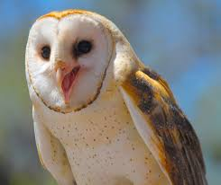

Birds range in size from thumb-sized hummingbirds to ostriches larger than a big man. Most birds, of course, fall somewhere between these two extremes. One common bird, the American Robin is about 10 inches in length, approximately the hands pan of a large man. The smallest American birds are some species of hummingbird that could nest and raise a family in the cupped palm of a child. The largest are the cranes and herons, which, when standing erect, are almost eye-to-eye with a human adult. The nearly extinct California Condor has a wing span of almost 10 feet, and the Bald Eagle spans 7 feet.

Birds walk, run, hop, swim, perch, cling, fly and even dig. They live in woodlands, open areas, cities, farms, lakes, swamps -- even the open ocean. They lay their eggs and raise their young in holes in the ground, in nests of varying complexity in vegetation or on the ground, in holes in trees, in human-constructed nest boxes and in or on various parts of buildings.

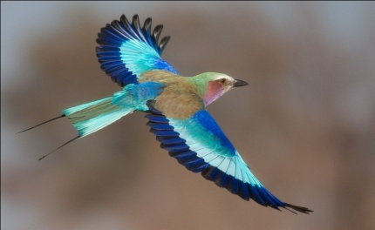 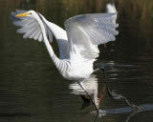

Evolutionary History:

According to the best evidence paleontologists have found, birds evolved from dinosaurs or from a near relative of the dinosaurs during the Mesozoic Era. Early types of birds had teeth -- unlike modern birds which have toothless beaks -- and seemed intermediate between their reptilian ancestors and their modern descendents. Birds evolved feathers and light hollow bones which allow them to fly, though some species later returned to life on solid ground. Flying birds have powerful muscles anchored to special bones in the breast.

## Migration :

Many birds are migratory, nesting and raising their young in temperate or higher latitudes during the warm months and spending the winter in tropical or sub-tropical areas. Some of these species make prodigious journeys of thousands of miles twice a year. The Arctic Tern nests in high latitudes of the northern hemisphere and spends the rest of the year at the opposite end of the earth, the high latitudes of the southern hemisphere. The thumb- sized Ruby-throated Hummingbird crosses the Caribbean non-stop twice each year. At the beginning of the journey, it rests and fills up on food to provide it energy for this tremendous feat.

## Bird songs :

Bird voices are often the key to their identification. Some species can hardly be told apart without hearing them call. The songs we hear in our gardens -- generally in the spring and summer -- are territorial and mating advertisements. The song, usually sung by a male, announces that he has staked out a particular piece of turf for his own and warns other males away. At the same time, the song announces to interested females the presence of a potential father for their young.

The songs of birds vary from species to species, and skilled birders can identify the species in a particular area by sound alone. While some songs are often complex or variable and sometimes difficult to tell apart, most people can learn fairly quickly to identify a few of the most common near where they live. In fact, bird watching is really as much bird listening as it is anything else. For this reason, many people who are completely blind or have low enough vision not to be able to see birds in the field can have be very successful in identifying the species around them.

Not all birds sing, but they usually make other identifiable sounds. The familiar call of the various species of Chickadee in North America isn't actually a song, but rather a call indicating excitement or alarm. The actual song of Chickadees is much more obscure. Birds make a variety of sounds ranging from territorial announcements to feeding announcements, to squeaks and chirps that serve to identify them to other birds -- and to observant humans. Owls, crows, chickadees, whip-poor-wills and many others are readily recognized as far away as they can be heard. With practice, the various notes of most birds can become as familiar as the caw of the crow.

## Birding as a hobby :

The hobby of birding, often called bird watching, is open to all, regardless of level of vision. All that is needed is a way to learn the sounds, and an open window. The person listening carefully from a window, even in the city, can soon learn a great deal about the bird populations in the area and how that and the behavior of the birds changes by season. Those in the east soon learn that tree swallows and phoebes are the first consumers of flying insects to return in the spring.

Perhaps the greatest pleasure to be derived from birding is the exchanging of observations with others with like interests. Among knowledgeable people, the arrival of the first tree swallow of the season, or the first phoebe is a source of shared excitement.

And there is a beauty to birdsong, too. Anyone who has heard the Hermit Thrush or the Common Loon doesn't need to be told that there is music in the natural world.

Eight hundred or more species of birds have been found somewhere in North America at one time or another. Some 8,000 are known worldwide. While not all these birds may be readily identified by sound, specialists feel that if they were placed anywhere in the world, they would be able to tell their location without any clues other than the voices of birds around them.

## Scientific observation :

The skillful observer of birds can contribute to the scientific knowledge of bird movements and to the science of ecology. Remember that miners used to carry a canary into the mines with them because birds are more sensitive to air quality than are humans. By watching the canary, the miners could tell if conditions dangerous to them were developing. So by paying attention to the behaviors and numbers of birds -- in organized bird counts and informally -- we all serve as observers of the miner's canaries of nature that let us know when dangerous conditions for humans may be developing through environmental damage. Reduced numbers of songbirds in eastern forests in recent years has reinforced the observation that the destruction of tropical forest wintering habitat and nesting habitat in our own forests may be reaching dangerous proportions.  An introduction to nature :

Birds may be only the starting point for the blind nature enthusiast. There are other sounds to learn that give cues to the world around. There are sounds of frogs and insects to learn that add depth and dimension to perceptions. The whisper of wind in the trees varies depending on type of tree and season of the year. Wildflowers and many trees and shrubs can be distinguished by scent; plants can be identified by feel. With practice, a person can tell something about what kind of forest he or she is in by how the leaf litter feels and sounds under foot.

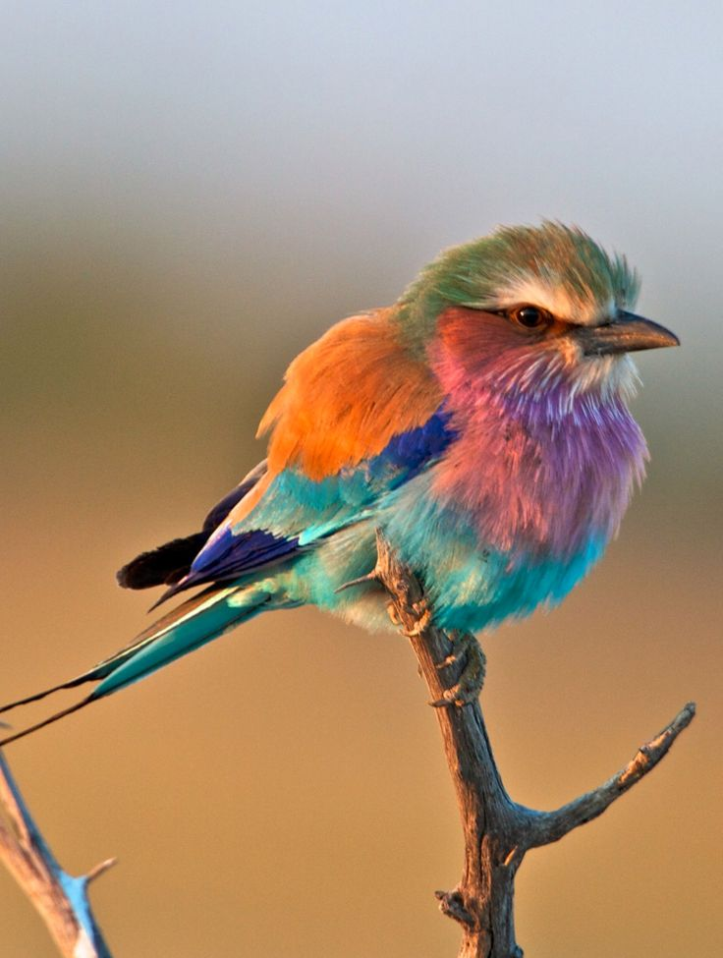 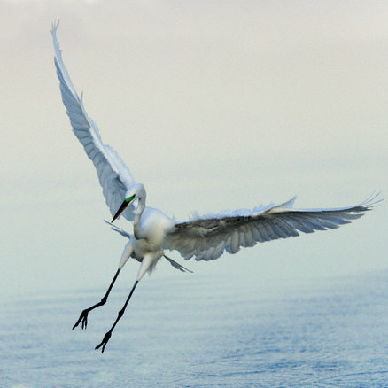

# Flightless Birds :

[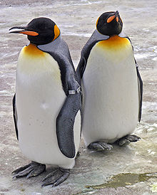](https://en.wikipedia.org/wiki/File:Penguins_Edinburgh_Zoo_2004_SMC.jpg)

[Penguins](https://en.wikipedia.org/wiki/Penguin) are a well-known example of flightless birds.

Flightless birds are [birds](https://en.wikipedia.org/wiki/Bird) that have evolved the inability to [fly](https://en.wikipedia.org/wiki/Flight). There are over 40 extant species including the well known [ratites](https://en.wikipedia.org/wiki/Ratites) ([ostrich](https://en.wikipedia.org/wiki/Ostrich), [emu](https://en.wikipedia.org/wiki/Emu), [cassowary](https://en.wikipedia.org/wiki/Cassowary), [rhea](https://en.wikipedia.org/wiki/Rhea_(bird)) and [kiwi](https://en.wikipedia.org/wiki/Kiwi)) and [penguins](https://en.wikipedia.org/wiki/Penguin). The smallest flightless bird is the [Inaccessible Island rail](https://en.wikipedia.org/wiki/Inaccessible_Island_rail)(length 12.5 cm, weight 34.7 g). The largest (both heaviest and tallest) flightless bird, which is also the largest living bird, is the [ostrich](https://en.wikipedia.org/wiki/Ostrich) (2.7 m, 156 kg). Ostriches are farmed for their decorative feathers, meat and their skins, which are used to make leather. Many domesticated birds, such as the [domestic chicken](https://en.wikipedia.org/wiki/Domestic_chicken) and [domestic duck](https://en.wikipedia.org/wiki/Domestic_duck), have lost the ability to fly for extended periods, although their ancestral species, the [red junglefowl](https://en.wikipedia.org/wiki/Red_junglefowl) and [mallard](https://en.wikipedia.org/wiki/Mallard) respectively, are capable of extended flight.

Flightlessness has evolved in many different birds independently. There were also other families of flightless birds, such as the now extinct [Phorusrhacidae](https://en.wikipedia.org/wiki/Phorusrhacidae), that evolved to be powerful terrestrial predators. Taking this to a greater extreme, the [terror birds](https://en.wikipedia.org/wiki/Terror_birds), [Gastornithiformes](https://en.wikipedia.org/wiki/Gastornithiformes), and [dromornithids](https://en.wikipedia.org/wiki/Dromornithidae) (all extinct) all evolved similar body shapes (i.e. long legs, long necks and big heads), yet none of them were closely related. Furthermore, they also share traits of being giant, flightless birds with vestigial wings, long legs, and long necks with some of the [ratites](https://en.wikipedia.org/wiki/Ratites), although theyare not related. 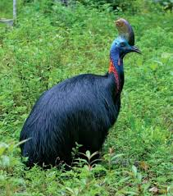

## Origins of flightless

Divergences and losses of flight within ratite lineage occurred after the K/T boundary’s mass extinction wiped out all non-avian dinosaurs and large vertebrates 65 Ma The immediate evacuation of niches following the mass extinction provided opportunities for Palaeognathes, to distribute and occupy novel environments. New ecological influences selectively pressured different taxon to converge on flightless modes of existence by altering them morphologically and behaviorally. The successful acquisition and protection of a claimed territory selected for large size and cursoriality in Tertiary ancestors of ratites. Temperate rainforests dried out throughout the Miocene and transformed into semi arid deserts causing habitats to be widely spread across the growingly disparate landmasses. Cursoriality was an economic means of traveling long distances to acquire food that was usually low laying vegetation and more easily accessed by walking. Traces of these events are reflected in ratite distribution throughout semi-arid grasslands and deserts today

Gigantism and flightless are almost exclusively correlated. This is mostly observed in islands lacking predators and competition. However, ratites occupy environments that are mostly occupied by a diverse amount of mammals. It is thought that they first originated through allopatric speciation caused by breakup of the supercontinent Gondwana. However recent evidence suggests this hypothesis first proposed by Joel Craft in 1974 is incorrect. Rather ratites arrived in their respective locations via a flightless ancestor and lost the ability to fly multiple times within the lineage.

Gigantism is not a requirement for flightless. The kiwi does not exhibit gigantism along with tinamous, even though they co-occur with the moa and rhea that both exhibit gigantism. This could be the result of ancestral flightless birds arrival or because of competitive exclusion. The first flightless bird to arrive in each environment utilized the large flightless herbivore or omnivore niche, forcing the later arrivals to remain smaller. In environments where flightless birds are not present, it is possible that after the K/T Boundary there were no niches for them to fill. They were pushed out by other herbivorous mammals.

[New Zealand](https://en.wikipedia.org/wiki/New_Zealand) has more species of flightless birds (including the [kiwis](https://en.wikipedia.org/wiki/Kiwi), several species of [penguins](https://en.wikipedia.org/wiki/Penguin), and the [takahe](https://en.wikipedia.org/wiki/Takahe)) than any other country. One reason is that until the arrival of humans roughly a thousand years ago, there were no large land predators in New Zealand; the main predators of flightless birds were larger birds.

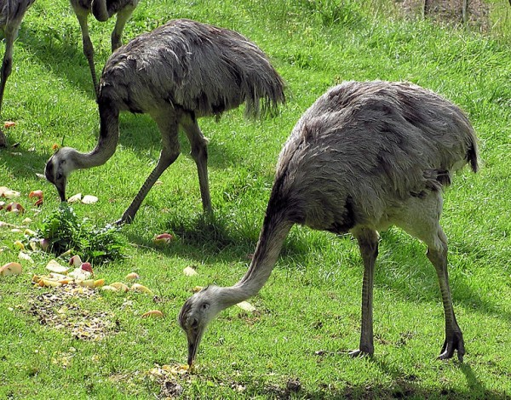

# Independent evolution of flightless in Paelaeognathes :

Ratites belong to the super order [Palaeognathae](https://en.wikipedia.org/wiki/Palaeognathae) birds, which include the volanttinamou, and are believed to have evolved flightless independently multiple times within their own group. Some birds evolved flightless in response to the absence of predators, for example on [oceanic islands](https://en.wikipedia.org/wiki/Oceanic_island). Incongruences between ratite phylogeny and Gondwana geological history indicate the presence of ratites in their current locations is the result of a secondary invasion by flying birds.[[16]](https://en.wikipedia.org/wiki/Flightless_bird#cite_note-16) It remains possible that the most recent common ancestor of ratites was flightless and the tinamou regained the ability to fly. However, it is believed that the loss of flight is an easier transition for birds rather than the loss and regain of flight, which has never been documented in avian history.Moreover, tinamou nesting within flightless ratites indicates ancestral ratites were volant and multiple losses of flight occurred independently throughout the lineage. This indicates that the dist

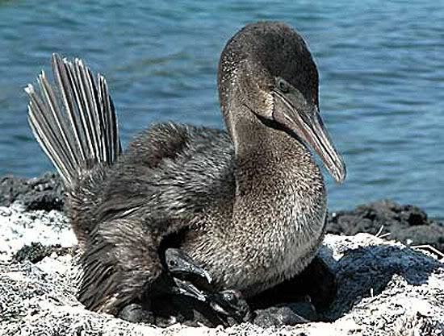

Continued presence of wings in flightless birds

Although selection pressure for flight was largely absent, the wing structure has not been lost except in the New Zealand mass. Ostriches are the fastest running birds in the world and emus have been documented running 50 km/hr. At these high speeds, wings are necessary for balance and serving as a parachute apparatus to help the bird slow down. Wings are hypothesized to have played a role in sexual selection in early ancestral ratites and were thus maintained. This can be seen today in both the rheas and ostriches. These ratites utilize their wings extensively for courtship and displays to other males. Sexual selection also influences the maintenance of large body size, which discourages flight. The large size of ratites leads to greater access to mates and higher reproductive success. Ratites and tinamous are monogamous and mate only a limited number of times per year. High parental involvement denotes the necessity for choosing a reliable mate. In a climactically stable habitat providing year round food supply, a male’s claimed territory signals to females the abundance of resources readily available to her and her offspring. Male size also indicates his protective abilities. Similar to the emperor penguin, male ratites incubate and protect their offspring anywhere between 85–92 days while females feed. They can go up to a week without eating and survive only off fat stores. The emu has been documented fasting as long as 56 days. If no continued pressures warrant the energy expenditure to maintain the structures of flight, selection will tend towards these other traits.

Introduction of student

Lamiah Mansoor

Zoology bs-i

TOPIC:-

**FLYING AND NON-FLYING BIRDS**

**Flying Birds:-**

Introduction

Birds are warm bodied creatures with wings and feathers. The body temperature of birds is generally higher than that of humans, so they seem warm to the touch. Birds lay eggs which they incubate until hatching -- or, in some cases, get some other bird to do the incubating. In some species such as our songbirds, the young hatch naked and helpless and must be fed and cared for by a parent bird. Others, like the chickens and their relatives, produce down-covered young that are able run about and feed themselves. They are still dependent for protection upon adult birds.

Introduction of student

Hafiza rohma abid

Zoology bs-i

**TOPIC:-**

BIRDS THAT HAVE COLORFULL FEATHERS

Introduction:

Birds have several types of feathers of various shape and sizes, which are specialized to serve different functions. Feathers come in a variety of colors, ranging from dull neutrals to bright and sometimes iridescent hues. The dull coloring of most females in no accident either. Female birds are most often brown or green, providing them camouflage while they care of their young in the nest.

A few speies of birds do exists in which the females are larger and more colorful than males. Interestingly, in these intances, mating roles are typically reverse.

Following are some of them*:*

* Lesser bird of paradise
* **Wilson's bird-of-paradise**
* **Albatross**
* **booby**

**COLOURFULL FEATHERS**

**1:**  **LESSER BIRD OF PARADISE:**

|  |  |
| --- | --- |
| Kingdom: | [Animalia](https://en.wikipedia.org/wiki/Animal) |
| Phylum: | [Chordata](https://en.wikipedia.org/wiki/Chordate) |
| Class: | [Aves](https://en.wikipedia.org/wiki/Bird) |
| Order: | Passeriformes |
|  |  |
|  |  |

**Introduction:**

The Lesser Bird-of-paradise is medium-sized, up to 32 cm-long, maroon-brown with a yellow crown and brownish-yellow upper back. The male has a dark emerald-green throat, a pair of long tail-wires and is adorned with ornamental flank plumes which are deep yellow at their base and fade outwards into white. The female is a maroon bird with a dark-brown head and whitish underparts.

**Breeding:**

The males are polygamous, and perform courtship displays in leks (competitive mating displays or dancing grounds).The female usually lays two pinkish eggs with dark markings in a nest in a tree high above ground.

**Courtship:**

Polygynous. Lekking males attend traditional tree perches that they defoliate. Up to 12 adult males may display in single lek tree, often with several female-plumaged young males in attendance. Dominant and older males occupy centre of lek and perform most copulations. Male briefly holds wings in front of body and throws flank plumes over back, then hops up and back along perch raising or lowering bill on each trip; he again raises plumes over back before moving to low point of perch and hanging facing downwards with plumes out; male lowers body along perch, extends wings, erects plumes and hops along branch calling.

